Smith Chart Homework 2 (21 Points)
(jas, Smith Chart HW2.docx, 10/7/2025)

For the following homework it is recommended that you use the Interactive Smith Chart available at: Applied Electromagnetics 8E Textbook Website. The Interactive Modules, are located under Student Resources. Go to Chapter 2: Transmission Lines 2.6 – Interactive Smith Chart for this homework. You can also use a printed Smith Chart along with compass, pencil and ruler. A Smith Chart pdf is available in Canvas in the Course Specifics module if a printed copy is needed.

- Use the Interactive Smith Chart or a printed Smith Chart and ruler to find the reflection coefficient at the load in polar form, i.e., $Γ_{L}=\left|Γ_{L}\right|∠θ_{r}$, with the angle $θ_{r}$ in degrees for the following load impedances. For the Interactive Smith Chart, simply enter reasonable line ($Z_{0}$) and load ($Z_{L}$) impedance values by means of the Set Line and Set Load panes, to arrive at the desired ${Z_{L}}/{Z_{0}}$ ratio, and then read off the corresponding reflection coefficient value $Γ_{L}$. For $Z_{L}=∞$, which implies $∞$ + j0, enter a very large number such as 99999999 for the real part, along with 0 for the imaginary part of Z_{L}. It is not necessary to include a screen shot of the Interactive Smith chart for your answer, rather just include the corresponding reflection coefficient in polar form. For a printed Smith chart, using the same ruler to measure the two different lengths required to determine $\left|Γ_{L}\right|$ results in a ratiometric measurement, which gives the correct ratio independent upon the size of the Smith Chart. Because of limited measurement resolution with printed Smith Chart measurements, reasonable variation is allowed between your resulting answer from the Smith Chart and the formula $Γ=\frac{{Z_{L}-Z}_{0}}{{Z_{0}+Z}_{L}}=\frac{1-\frac{Z_{o}}{Z_{L}}}{\frac{Z_{o}}{Z_{L}}+1}$, which can be used to check your answers.

- $For Z_{L}=Z_{0}$, $Γ_{L}=0∠0°$ (2 points.)

- $For Z_{L}=∞$, $Γ_{L}=1∠0°$ (2 points.)

- $For Z_{L}=0$, $Γ_{L}=1∠180°$ (2 points.)

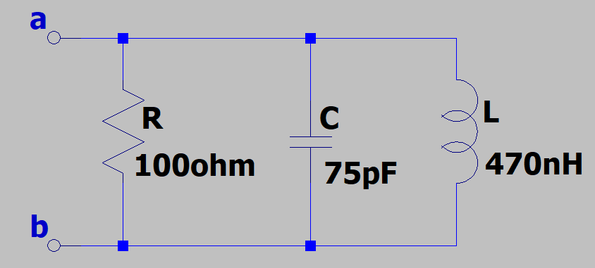
- Determine the equivalent admittance of the adjacent circuit in polar form with the angle in units of degrees, at a frequency of 40 MHz. Be sure to include units. (Hint: Admittance magnitude should be somewhere between 12 mS and 20 mS Siemens (S). Admittance phase angle should be somewhere between 40 and 50˚.) (3 Points.)

$$Y_{T}=\frac{1}{Z_{T}}=\frac{1}{R}+\frac{1}{jωL}+jωC$$
$$Y_{T}=\frac{1}{100}+\frac{1}{j2π(40*{10}^{6})(470*{10}^{-9})}+j2π(40*{10}^{6})(75*{10}^{-12})$$
$$Y_{T}=0.01+j0.0104 Ω$$
$${|Y}_{T}|=\sqrt{{0.01}^{2}+{0.0104}^{2}}=0.0144 S$$
$$θ_{Y}= \tan^{-1}\left(\frac{0.0104}{0.01}\right)=46.12°$$
$$Y_{T}=14.4∠46.12° mS$$

- You are to shunt (parallel) element match a load impedance of $Z_{L}=\left(30-j60\right)Ω$ to a 75 Ω feedline at f = 110 MHz, using either a parallel inductor or capacitor. It is recommended that you follow the Smith Chart Solution procedure given in Example 2-13 from the text and/or class slides for lumped element matching.

While the Interactive Smith Chart is recommended, the printed Smith Chart illustrated in Figure 2-36 of the text can be used, as it includes the needed SWR circle and $g_{L}=1$ circle. The circuits illustrated in Figure 2-35 have the correct shunt element form, but not the correct values, for the two possible shunt element solutions to this problem. You only need to solve one of the two possible shunt element solutions. Your answer should include the following values: (12 points total.)

- Normalized load Impedance: $z_{L}=r_{L}+jx_{L}$. (1 Point.)
$$Z_{L}=\frac{Z_{L}}{Z_{0}}=\frac{\left(30-j60\right)Ω}{75 Ω }=0.4-j0.8$$
- Normalized load admittance: $y_{L}=g_{L}+jb_{L}$. (1 Point.)
$$Y_{L}=\frac{1}{Z_{L}}=\frac{1}{0.4-j0.8}=\frac{0.4+j0.8}{{0.4}^{2}+{0.8}^{2}}=0.5+j1$$
- Normalized Admittance at distance d from load: $y_{d}=g_{d}+jb_{d}$. (Note: Round $g_{d}$ values > 0.99 to 1, as ideally $g_{d}$ = 1.) (1 Point.)
$$y_{d}=1.00+j1.58$$

- Distance d from load to shunt element in terms of λ. (2 Points.)
$$d=0.0433λ$$
- Normalized shunt admittance $y_{s}.$ (3 points, 1 point for sign.)
$$y_{s}=-j1.58$$
- Value of shunt inductance or capacitance, i.e., L or C, for lumped element matching. (Hint: Inductance value should be in the range of 50 to 85 nH, while capacitance value should be in the range of 20 to 40 pF.) (4 Points.)

$$Y_{s}=-j1.58*\frac{1}{75}=-j0.0211 S$$
$$Z_{s}=\frac{1}{-j0.0211 }Ω=j47.7 Ω$$
$$Z_{L}=jωL→L=\frac{Z_{L}}{jω}=\frac{j47.7Ω}{j2π*110*{10}^{6}}=69 nH$$

